**NOTICE OF PUBLIC EXHIBITION**

**PLANNING PROPOSAL**

**Reclassification of Lot 848 of DP 703278 (John Arthur Ave), Part Lot 1538 of DP 832922 and Part Lot 8884 of DP 786883 (Thomas Coke Drive).**

**From 'Community Land' to 'Operational Land'**

Pursuant to section 3.34(2)(c) and schedule 1 clause 4 of the *Environmental Planning and Assessment Act 1979*, notice is hereby given of the public exhibition of a Planning Proposal to amend Maitland Local Environmental Plan 2011. The Planning Proposal is seeking reclassification of (Lot 848 of DP 703278 (John Arthur Ave), Part Lot 1538 of DP 832922 and Part Lot 8884 of DP 786883 (Thomas Coke Drive). For the purpose of legal and practical access to an intended residential subdivision. (Figure 1).

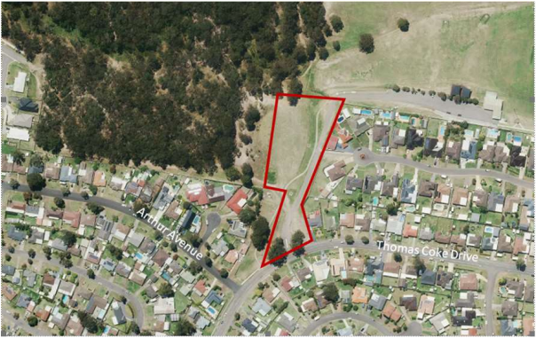

Figure 1 : Site Location: Thornton

Note. The proposed reclassification of Item 2 does not impede the current access arrangement to Allan & Don Lawrence Fields.

The Planning Proposal and supporting information will be on exhibition from **Wednesday 24 July 2024 until Friday 26th August 2024** at Council’s Customer Service Centre, High Street, Maitland and Council libraries.

Download:

1. Planning Proposal
2. Gateway Determination
3. Council Report and Resolution
4. LEP Practice Note - Classification and reclassification of public land through a local environmental plan

Persons wishing to comment on the Planning Proposal should do so by **5.00pm** on **Friday 26th August 2024** and should quote reference no: **RZ 22/001**. Submissions should be addressed to The *CEO, Maitland City Council, PO Box 220, Maitland NSW 2320.*

In accordance with the *Local Government and Planning Legislation Amendment (Political Donations) Act 2008*, any person making a written submission after 1 October 2008 – either for or against a proposal – must also make a disclosure if the person has made a reportable political donation. If relevant, please include a completed “Statement of Political Donations and Gifts” form with your submission. This form can be found on Council’s website at [*www.maitland.nsw.gov.au*](http://www.maitland.nsw.gov.au) or obtained from Council’s Customer Service Counter and all libraries during opening hours.

Further enquiries should be directed to Gary Hamer on (02) 4934 9800.